**1. Share Applicants: Epic**

**Description:**  
As a user, I’d like to share the applicants of a particular job with their colleagues such that they can provide their feedback on those applicants and the right candidate could be hired.  
  
**1.1 Recruiter- Sharing applications (Sender)- Story**  
**Description:** As a user, I’d like to share the applicants of a particular job with other people such that they can provide their feedback on those applicants and the right candidate could be hired.  
**Acceptance Criteria:**  
--> Once a user selects the “Share applicants” button in the View applicants page of a job, then a pop up should appear on screen.  
--> This pop up should include a title as “Share applicants” followed by “To” and a text field.  
--> This text field should accept only email IDs, (only Official IDs) and unofficial both.  
--> A user should be able to add any number of email IDs in this field. Also, should be able to delete them. However, at least one email should be provided by the user to move forward.  
--> Below the email text field, a check box should also be provided for the user to decide whether to share the salary details of applicants with the receiver or not.  
--> If the user wishes to Hide the salary, then in the receiver’s view, the salary field should be blurred (completely) to view in the applicant’s full details page and should be hidden in the applicant’s card (applicant’s list view)  
--> Once the user enters email IDs, then the Share button should be enabled for the user to share the applicants.  
--> Once the user selects “Share” button, then an email has to be shared with all the recipients.  
--> The subject and body of this email should be:  
Sub: Access applicant list & provide feedback  
Body:  
Dear {{Recipient}},

{Recruiter Name} has shared a list of applicants, applied for {job title} for your review. You can access the list using the link below and provide your feedback.  
{Link}  
To proceed, please enter your email ID to get access.   
Your feedback is valuable and will help us make informed hiring decisions. Let us know if you have any questions!  
Best regards,  
{Recruiter Name}

{Designation}  
{Company name}  
Note: Recruiter’s name, designation and Company name are to be fetched from the 2-step form.  
  
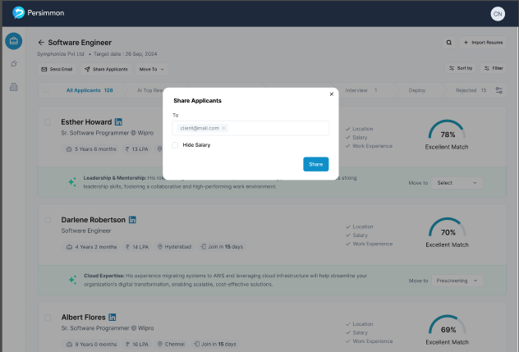

**1.2 Recruiter- Shared applications (Receiver)- Story**  
**Description:**  
As a user, I’d like to view the shared applications and to provide my feedback on those applicants such that the right candidate could be hired.  
**Acceptance Criteria:**  
--> Once a user clicks on the link, which they receive as an email, they should be taken to persimmon in a new tab.  
--> However, they should land on the Provide email screen instead of Login/Sign up.  
--> This page/Screen should consist of a Modal box on top of a dummy applicant’s page (Blurred out)  
--> This modal box should include a title as {Recruiter’s email} has shared {number of applications shared} applicants for {job title}.  
--> Followed by a text field with title as “Please enter your email ID to access”. This text field should only accept one email ID.  
--> If the user enters invalid email ID’s which aren’t the authorized (unavailable in the shared list of emails), then an error message should be displayed below the text field as “Invalid email ID”  
--> If the email is valid (available in the shared list), then the user should be taken to the shared list or shared applicant’s full details page (depending on what a recruiter shared)  
--> If the sender (Recruiter) has opted for Hide salary, then the salary in the applicant’s list has to be hidden. Also, in the applicant’s full details page, the Current CTC and Expected CTC fields should be blurred.  
--> However, for the users who access applicant’s profile from the link, the only tabs to be available are:  
i. Basic details  
ii. Resume  
Also, an option at the right of the screen to provide feedback on that applicant.  
  
**1.2.1 Recruiter- Shared applications (Receiver)- Task**  
**Description:**  
As a user, I’d like to provide feedback for a shared applicant such that the recruiter should be able to view my analysis on the applicant’s profile.  
**Acceptance Criteria:**  
--> This feedback form on the right of the screen in every applicant’s full details page should include:  
i. Rating:  
-Skill   
-Communication   
-Professionalism  
* Note: For these 3 fields, 1 to 5 stars are to be provided for the user to select.  
--> A user can only select full portions, hence no partial filling of stars to be allowed.  
--> If a user selects 4th star, then all the first 4 stars are to be filled and to be displayed.  
--> Until the user submits their feedback form, they can change their response any number of times.  
--> This is a mandatory field, hence the user should not be able to submit their feedback unless they provide their response to this field.  
  
ii. Feedback  
--> This has to be a text field accepting both alphabetic and numeric values while accepting only few special characters as Punctuations (**.,?!:;'-"**), Brackets & Parentheses (**() {} [] <>**), Underscore & Hyphen (**_ -** ), Ampersand and At Symbol ( **& @**), Slash and Backslash (**/ \**)  
--> The minimum limit of characters is to be 50 characters while maximum to be 1000 characters.  
--> This is a mandatory field, hence the user should not be able to submit their feedback unless they provide their response to this field.  
  
iii. Opinion  
--> The title of this field should be “What’s your opinion?”  
--> Followed by Like and Dislike emojis (Symbols).  
--> User can either select one of these two or none of these. Hence, this is an optional field for the user to provide the response.  
--> By default, both these emojis should be in grey colour. However, once any of these gets selected, they should be highlighted in blue colour, indicating their preferred choice.  
  
iv. Submit  
--> Once the user provides valid data in all the mandatory fields (Optional fields too), then the Submit button should be available for the user to submit their response.  
--> Once the user submits their feedback, then their response should be sent to the recruiter and to be displayed for the recruiter (sender).  
--> However, for the user, their response has to be displayed for their reference in this feedback form area itself. Also, the Submit button should be replaced with a text as “Feedback submitted”  
  
--> This image represents how a feedback form should be displayed for the user.  
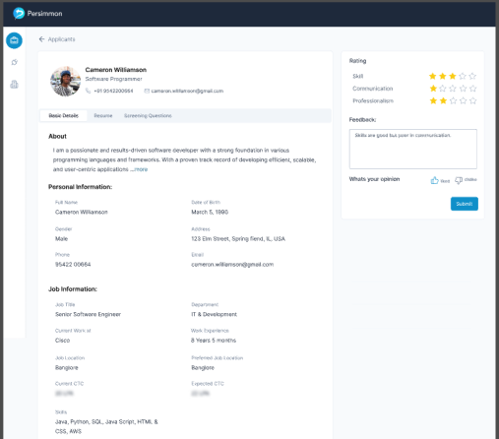  
  
--> This image represents the feedback form, after a user submits their response:  
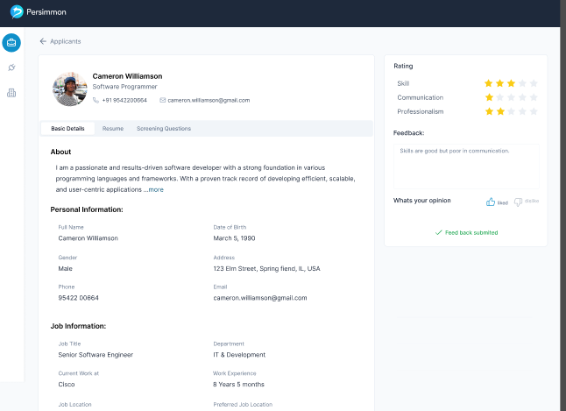

--> Below the feedback response texts, the opinions are also to be displayed and their count.  
  
--> All this history of responses are only to be displayed for recruiters (users) registered on persimmon for a same organization.  
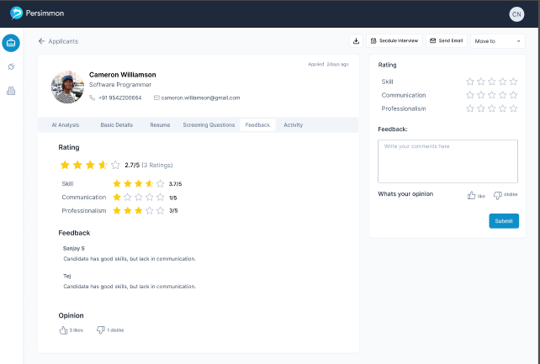  
  
  
**2. Career page integration (Modification)- Task**  
**Description:**  
As a user, I’d like to see only persimmon’s UI inside the careers page on my website, replacing all the elements including the footer.  
**Acceptance Criteria:**  
--> All the current implementations are to be untouched.  
--> However, the footer of target website should be replaced with Persimmon’s footer.   
--> This footer colour should be the same as mentioned in Figma  
--> In the middle of this footer, a static text to be displayed as “Powered by {Persimmon logo} Persimmon”.  
--> On clicking persimmon logo, it should redirect to persimmon website in a new tab (Sign up page).  
--> This implies that, all the elements visible on career’s page of target website should be of Persimmon only.  
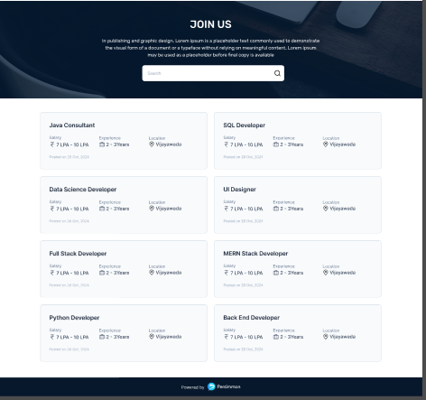  
  


**3 Recruiter- Profile- EPIC**  
As a user, I’d like to view and edit my profile, my organization profile and also should be able to change my account’s password.  
**3.1 Recruiter- View Profile-Profile tab Story**  
**Description:**  
As a user, I’d like to view my profile on Persimmon and edit the details if required.

**Acceptance Criteria:**  
--> Once the user selects the profile button on the top right corner of the screen, a dropdown with two options is to be displayed. They are:  
i. My Account  
ii. Logout  
  
(Existing Functionality)  
--> When a user selects “My Account”, then they should be taken to the Profile page, where the data should be displayed in three sets as:  
i. The first card should include the full name of user, email ID of user and Profile picture of user.  
In this card, only the profile picture is to be clickable. Hence, once a user selects this icon, the user’s device’s storage should be opened such that the user can upload an image of their choice (Only png, jpeg file types of up to 2MB are to be accepted).   
If the user has already uploaded one and trying to upload another, the older image has to be replaced by a new one.  
Also, the image has to be reflected (as a smaller version) in the profile icon at the top right corner of the screen. Until the user uploads a picture, by default, the first letter of first name and first letter of last name should be displayed as  
   
  
ii. The second data set is to be a horizontal menu tab with three options as  
- Profile  
- Organization  
- Password  
Whichever tab the user is in, that should be highlighted for the user to understand.  
  
iii. Data card.  
This card should include all the required fields with respect to the horizontal menu tab.  
  
  
For Profile tab:  
- Full name of the user  
- Designation of the user  
- WhatsApp number of the user  
- LinkedIn URL of the user has to be displayed  
(Note: All these fields should contain the same validations as the 2-step form of recruiter after they register into Persimmon)  
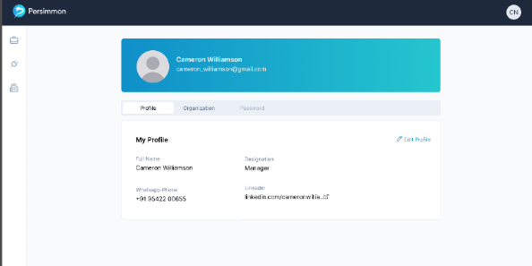  
  
--> This data card should also include an “Edit” button on the top right corner.  
--> On clicking this button, all the fields are to be editable and this button has to be replaced with two buttons as Tick mark (to save changes) and cross mark (to discard changes).  
  
--> This image is a reference of viewing  
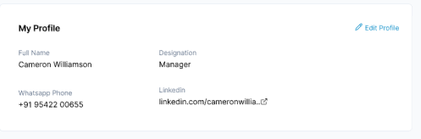  
  
--> This image is a reference of editing  
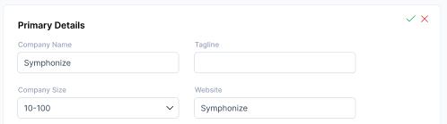

**3.2 Recruiter- View Profile-Organization tab Story**  
**Description:**  
As a user, I’d like to view my Organization details on Persimmon and edit the details if required.

**Acceptance Criteria:**  
--> Once the user selects the “Organization” button in the horizontal menu, the data card should load with all the respective fields. This data has to be divided into 4 cards as:  
i. Primary Details  
- Company Name  
- Tagline  
- Company Size  
- Website  
- Industry Type  
- Company Type  
- Business Type  
(Note: All these fields should contain the same validations as the 2-step form of recruiter after they register into Persimmon)  
  
ii. About  
This has to be a text field accepting both alphabetic and numeric values while accepting only few special characters as Punctuations (**.,?!:;'-"**), Brackets & Parentheses (**() {} [] <>**), Underscore & Hyphen (**_ -** ), Ampersand and At Symbol ( **& @**), Slash and Backslash (**/ \**) Plus (**+**)  
-->The minimum limit of characters is to be 50 characters while maximum to be 1000 characters.  
  
iii. Logo and Company images  
- Logo (should accept png, jpeg and upto 5 MB)  
- Company images (should accept png, jpeg and upto 5 MB each, upto 10 images)  
  
iv. Social Media  
- LinkedIn URL  
- Instagram URL  
- Facebook URL  
- Twitter URL  
(Note: All these fields should contain the same validations as the 2-step form of recruiter after they register into Persimmon)  
  
--> These data cards should also include an “Edit” button on the top right corner.  
--> On clicking this button, all the fields are to be editable and this button has to be replaced with two buttons as Tick mark (to save changes) and cross mark (to discard changes).  
--> This image is a reference of viewing  
  
  
--> This image is a reference of editing  
  
  
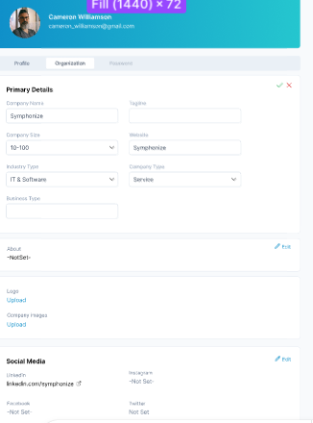  
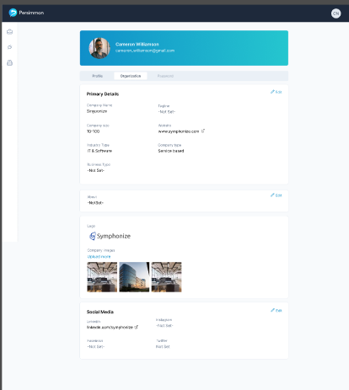  
  
  
  
  
  
**3.3 Recruiter- View Profile-Password tab Story**  
**Description:**  
As a user, I’d like to view my Organization details on Persimmon and edit the details if required.

**Acceptance Criteria:**  
--> Once the user selects the “Organization” button in the horizontal menu, the data card should load with all the respective fields, as follows  
i. Enter old password  
ii. Enter new password  
iii. Re-enter new password  
  
--> All these fields should follow all the validations of Password page (PER-99); which are:

- Min & Max Length must be 8-16 characters

- Should contain at least 1 number (0-9)

- Should contain at least 1 special character (e.g., !, @, #, $, etc.)

- Should contain at least 1 uppercase letter (A-Z)

- If the password does not meet any of the above criteria, an error message that should be displayed indicating which criteria were not met is "Password must be at least 8 characters long and contain one uppercase letter, one number, and one special character."  
  
-Recruiter should have the option to see or hide the password text they are entering, by selecting the "eye" icon

- Example of correct and incorrect passwords:  
i. Correct: Example@123  
ii. Incorrect: example, example@123, Example123

- If Recruiter enters Space as a character in the password field, the error message that should be displayed is "Spaces are not allowed. Kindly enter a valid password.".

- When the passwords doesn’t match, the error message that should be displayed is “Password Doesn’t Match“  
  
--> At the bottom of this card, “Save changes” button should be included. Upon selection, if the data is valid, their password should get updated and this button should change into a static text stating “Password changed successfully”, and fields should get empty after successful acknowledgement)

--> This is a reference image of empty fields:  
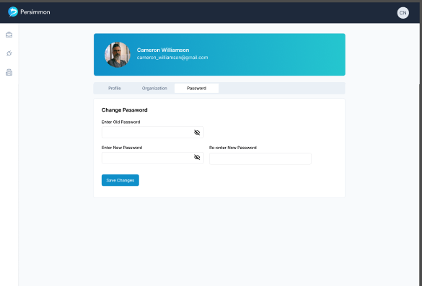

--> This is reference image of data inside the fields:  
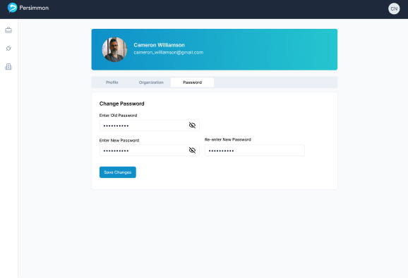  
  
Note: If the user signs up with LinkedIn SSO, then they should see this tab entirely. Hence, only two tabs are to be displayed in the horizontal menu.  
  
  
**4 Recruiter- Editing applicant’s Profile- Story**  
**Description:**  
As a user, I’d like to edit the details of an applicant on Persimmon, if required.

**Acceptance Criteria:**  
--> Once the user selects the “Basic details” tab inside the Applicant’s full details page, all the basic details are to be displayed. (Existing functionality)  
--> However, all these fields should be highlighted on hovering, stating that a recruiter can edit the data inside each field.

--> Existing screen:  
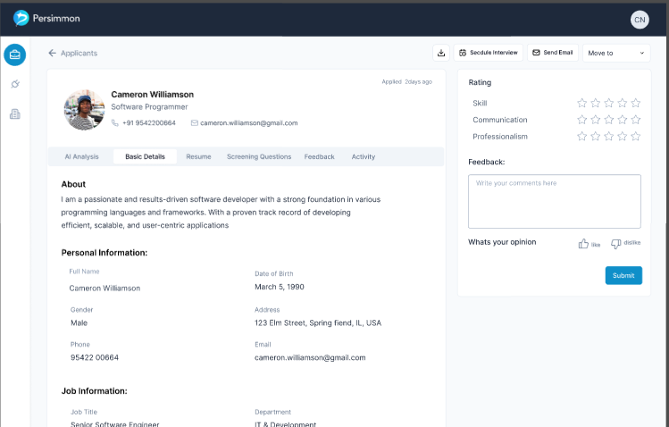

--> New UI (on hover):  
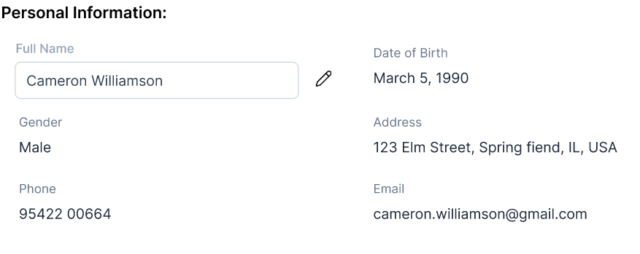  
In the above image, Full name field is being highlighted as the user has hovered on it.   
  
--> If the user selects edit icon beside the highlighted field, the edit icon should get replaced by Right tick mark (to save the changes) and Cross tick mark (to cancel or to discard the changes) and the respective field should become editable.  
  
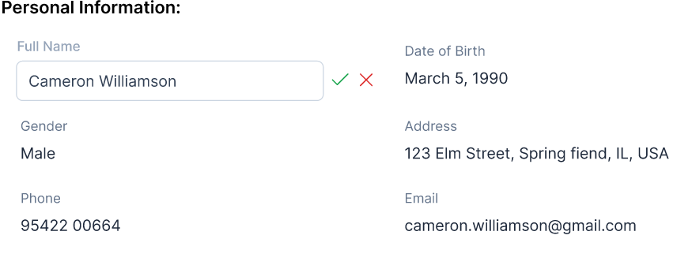

--> These basic details should be edited manually or even programmatically in the automation workflows.